Topic: Common Personality Traits

Tripti Vishwakarma
Colorado State University Global
Course Code: CSC 505-1
Jonathan Vanover
Jun 9 2024

Below is the UML diagram represents represents a class called Software Developer, which models the traits commonly associated with excellent software developers.

UML Diagram- 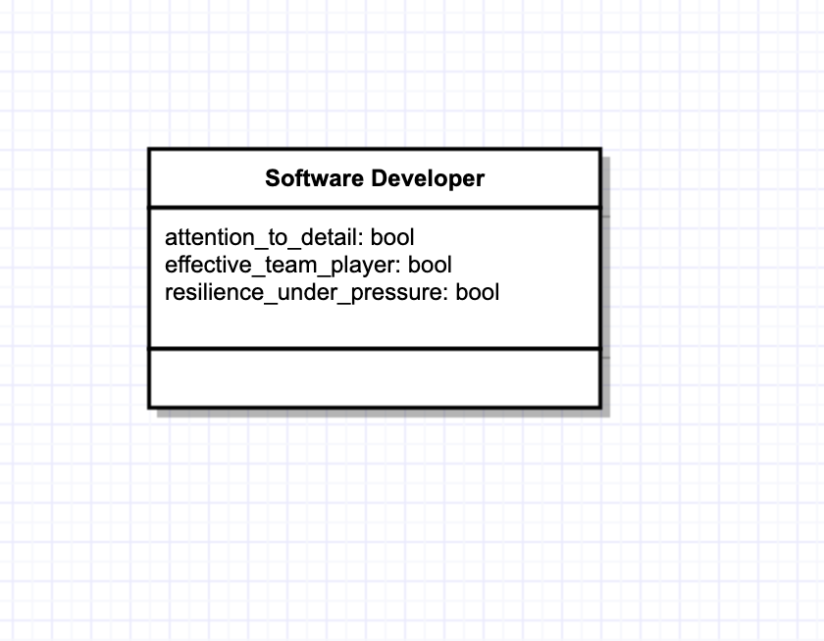

Here's an explanation of the diagram:

SoftwareDeveloper Class:

This class represents a software developer entity. It encapsulates three traits or characteristics that are often observed in excellent software developers. These traits are represented as attributes of the class.

Traits:

1. Attention to Detail:
- This trait reflects the ability of a software developer to pay close attention to the specifics and intricacies of tasks or code. Software developers with high attention to detail are meticulous and thorough in their work, which helps in producing high-quality code and products.
“An effective software engineer exhibits attention to detail. This does not imply an obsession with perfection. He carefully considers the broader criteria (e.g., perfor-mance, cost, quality) that have been established for the product and the project in making his daily technical decisions”
(Pressman & Maxim, n.d.)

2. Effective Team Player:
This trait indicates the capability of a software developer to collaborate effectively with team members. Effective team players contribute positively to team dynamics, communicate well, and collaborate seamlessly to achieve common goals.

“An effective software engineer has a heightened sense of fairness. She gladly shares credit with her colleagues. She tries to avoid conflicts of interest and never acts to sabotage the work of others”
(Pressman & Maxim, n.d.)

3. Resilience under Pressure:
- This trait describes the ability of a software developer to remain composed and perform well even in challenging or high-pressure situations. Resilient developers can adapt to changing circumstances, handle stress effectively, and maintain productivity during tight deadlines or demanding projects.

“An effective software engineer exhibits resilience under pressure. Software engi-neering is always on the edge of chaos. Pressure comes in many forms—changes in requirements and priorities, demanding stakeholders, and overbearing managers. An effective software engineer manages pressure so that his performance does not suffer” - (Pressman & Maxim, n.d.)

Below is the Python script that constructs a SoftwareDeveloper object with these traits based on user input and prints a brief description along with the names and number of important steps in the program.

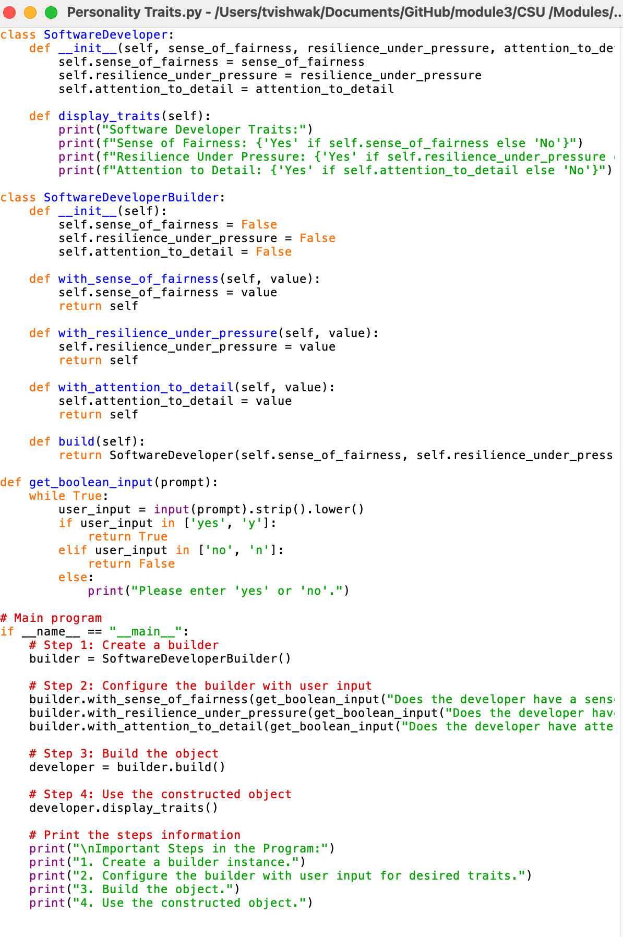
Code Execution-

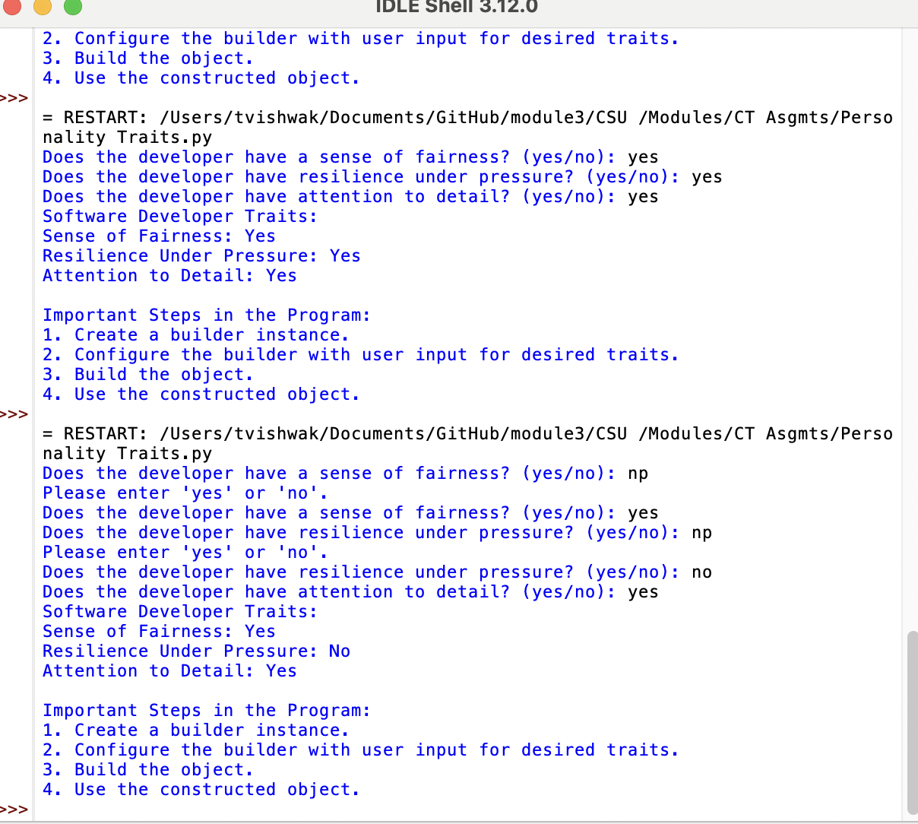

References –

Software Engineering: A Practitioner's Approach, (Pressman & Maxim)

https://platform.virdocs.com/read/1490446/108/#/4/4

Builder pattern object construction - https://www.oodesign.com/

Pluralsight. (2019). 20 patterns to watch for in your engineering teamLinks to an external site.. https://www.pluralsight.com/content/dam/pluralsight2/landing-pages/offers/flow/pdf/Pluralsight_20Patterns_ebook.pdf

